PROJECT NAME

*DEPLOY A STATIC WEBSITE ON AWS*

About the project : *In this project, we will learn how to create a static*

*website and deploy it using aws services. A static website is a site that consiste of*

*HTML, CSS files and it doesn’t require server-side processing or a database.*

Step1-

# sign in to aws management console

Step 2-

#create an s3bucket

*Make sure you are in the Asia pacific (Mumbai) ap-south-1.

*Navigate to the services menu and click on the top.then Click on s3 in the storage section.

*In the s3 dashboard, click on the create bucket button and fill in the bucket details.

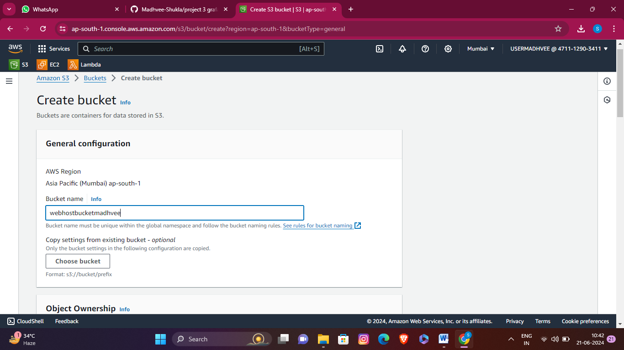

* all are as default.

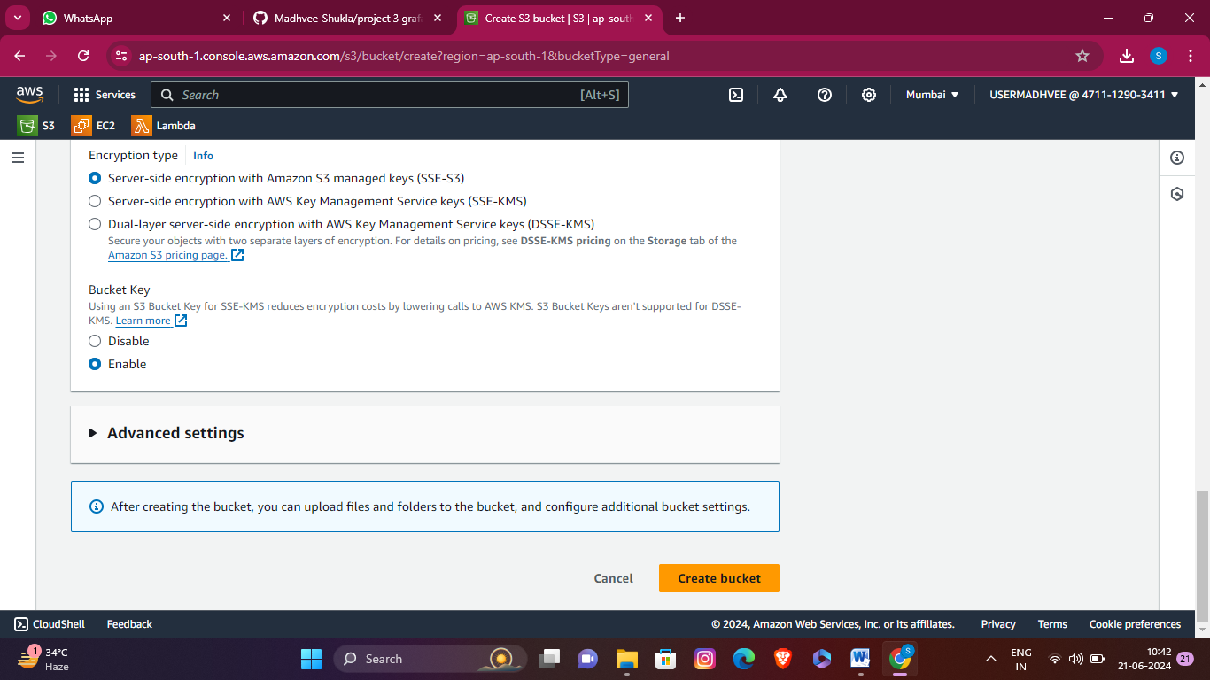

*Your bucket has been created successfully.

Step 3-

#Make a HTML file and upload it in s3 bucket

<!DOCTYPE html>

<html lang="en">

<head>

<meta charset="UTF-8">

<meta name="viewport" content="width=device-width, initial-scale=1.0">

<title>books</title>

<link rel="stylesheet" href="style.css">

</head>

<body>

<nav>

<ul>

<li><a href="#home">Home</a></li>

<li><a href="#about">About</a></li>

<li><a href="#services">Services</a></li>

<li><a href="#contact">Contact</a></li>

</ul>

</nav>

<header>

<div class="header-content">

<div class="library-info">

<h1>Welcome to Our Book Library</h1>

<p>Explore a vast collection of books covering various genres and topics.</p>

<p>Order online or visit our library to borrow books.</p>

</div>

<div class="book-info">

<div class="book-image">

<img src="https://webhostbucketmadhvee.s3.ap-south-1.amazonaws.com/1.jpeg" alt="Book Image">

</div>

<div class="book-details">

<h2>Harry Potter</h2>

<p>Author: J. K. Rowling</p>

<p>Description: Harry Potter is a series of seven fantasy novels written by British author J. K. Rowling. The novels chronicle the lives of a young wizard, Harry Potter, and his friends Hermione Granger and Ron Weasley, all of whom are students at Hogwarts School of Witchcraft and Wizardry.

</p>

<button>Order Now</button>

</div>

</div>

<div class="book-info">

<div class="book-image">

<img src="https://webhostbucketmadhvee.s3.ap-south-1.amazonaws.com/2.jpeg" alt="Book Image">

</div>

<div class="book-details">

<h2>jharana</h2>

<p>Author: Jay Shankar</p>

<p>Description: Lorem ipsum dolor sit amet, consectetur adipiscing elit. Ut aliquet felis nec eros fringilla, sit amet rutrum purus vehicula.</p>

<button>Order Now</button>

</div>

</div>

<div class="book-info">

<div class="book-image">

<img src="https://webhostbucketmadhvee.s3.ap-south-1.amazonaws.com/download.jpeg" alt="Book Image">

</div>

<div class="book-details">

<h2>The India way</h2>

<p>Author: Jay Shankar</p>

<p>Description:

The India Way primarily focuses on the contrast in business management styles between the U.S. and India. Topics discussed in the book include topics such as leadership skills, company governance, human resources management and innovation</p>

<button>Order Now</button>

</div>

</div>

</div>

</header>

<footer>

<div class="footer-content">

<p>&copy; 2024 Your Website Name. All rights reserved.</p>

<ul>

<li><a href="#">Home</a></li>

<li><a href="#">About</a></li>

<li><a href="#">Contact</a></li>

</ul>

</div>

</footer>

</body>

</html>

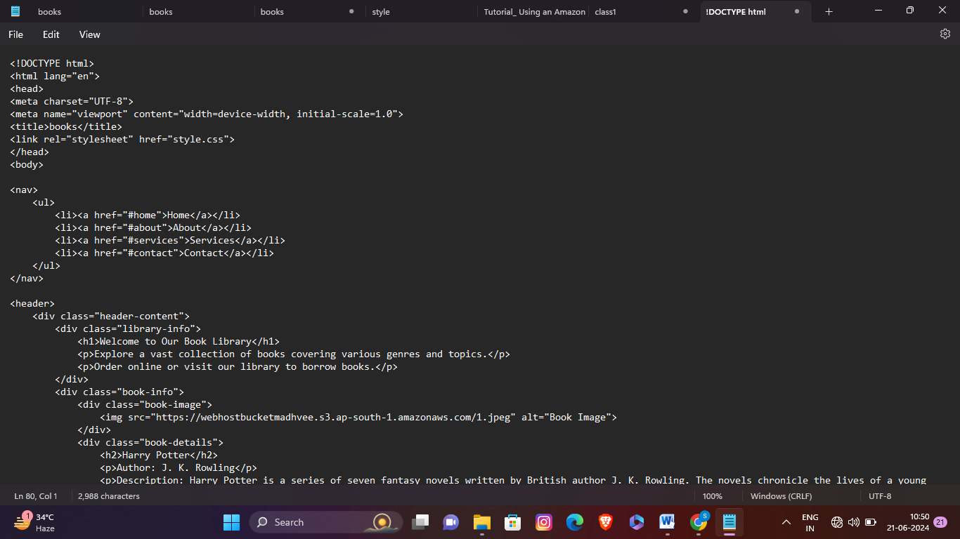

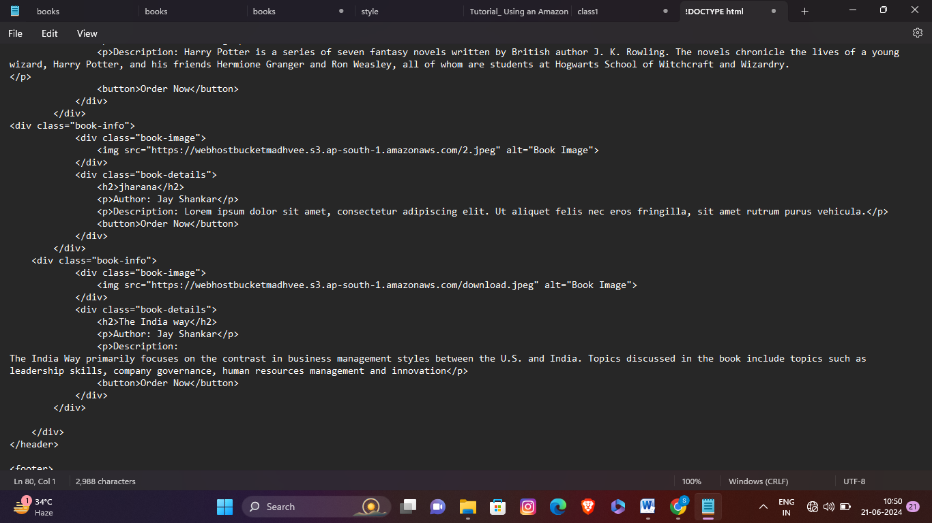

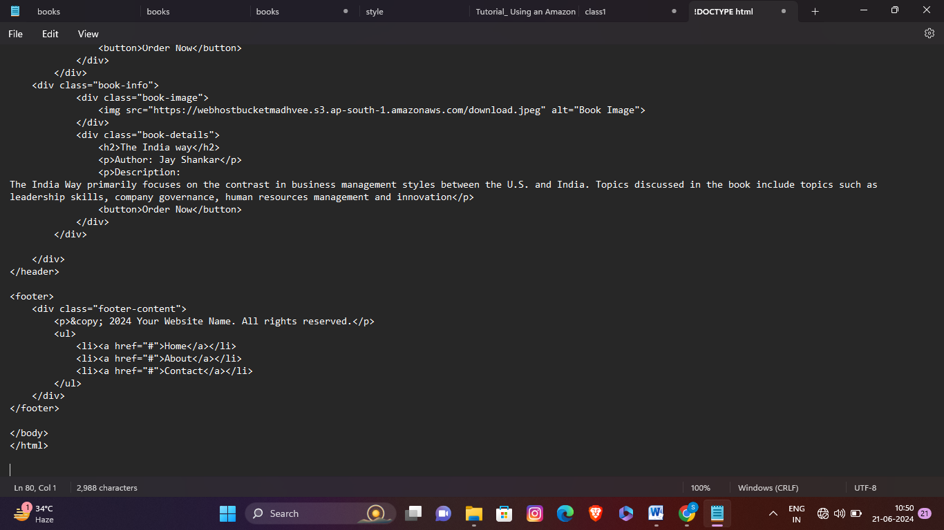

*Here, we have taken the code of book library in HTML and saved it in notepad with extension of book.html.

*Now, we will go to the s3 bucket and upload this html file.

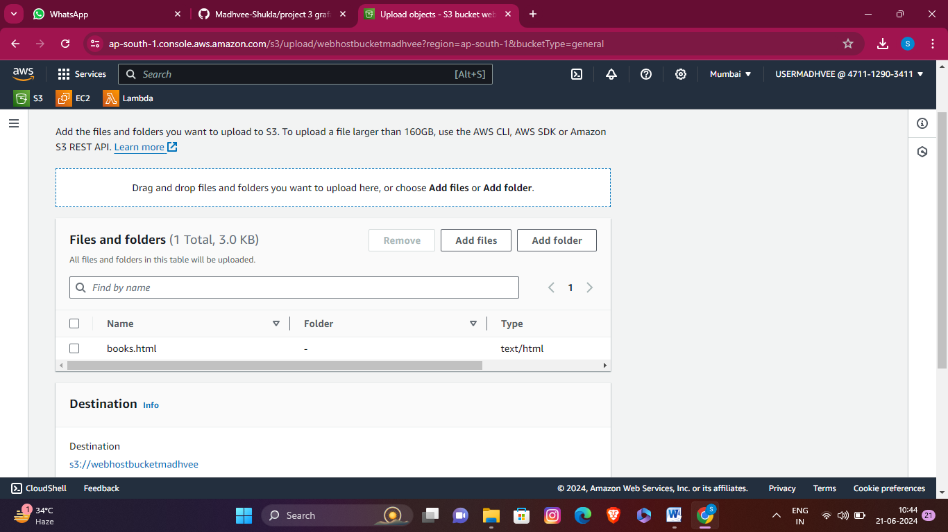

*once we uploaded our file then we will go to the objects and click the file. *We will also check properties and permissions of file .In ***properties*** we ***enabled our static webhosting***.

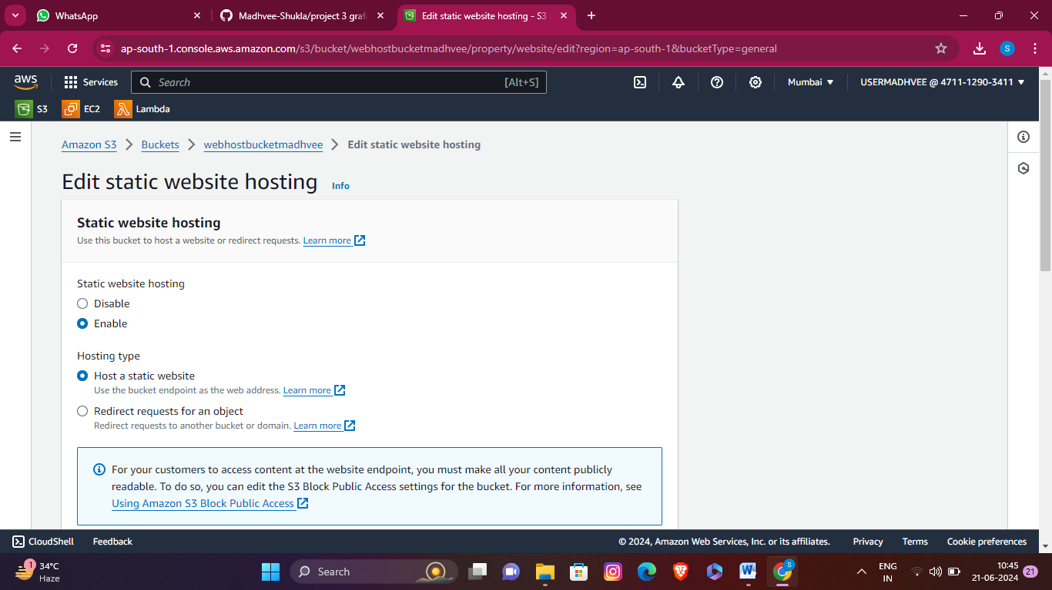

*we go to the ***permission tab*** and edit *block public access* ***from on to off***

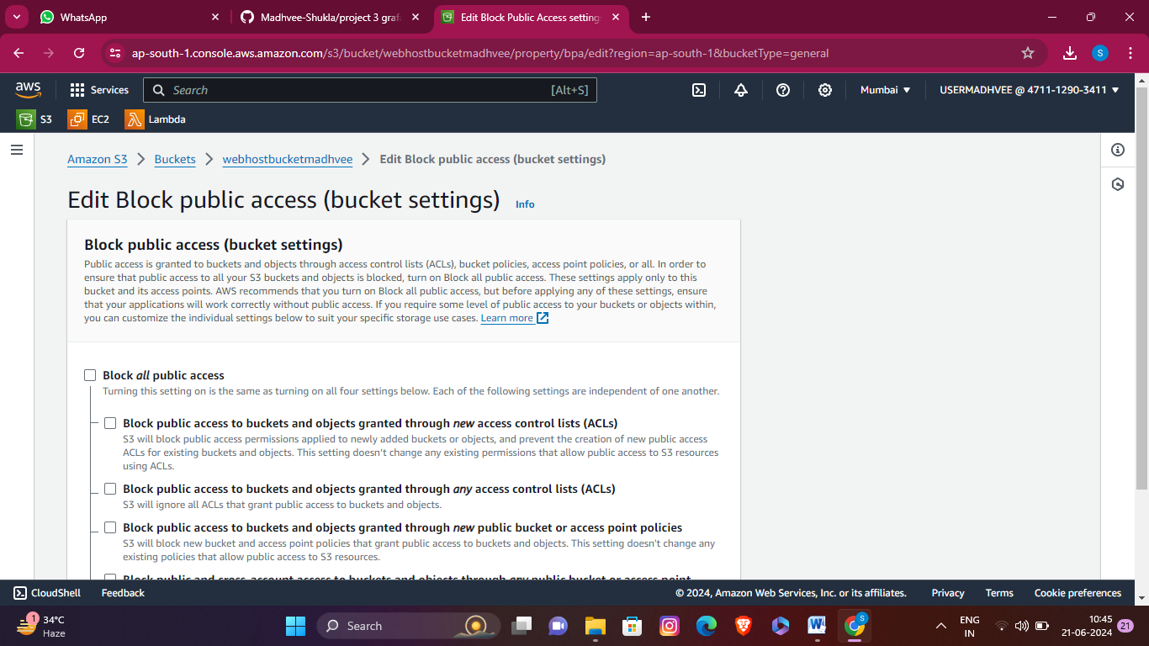

*Save changes

*we edit ***object ownership*** and select ***ACLs enabled***

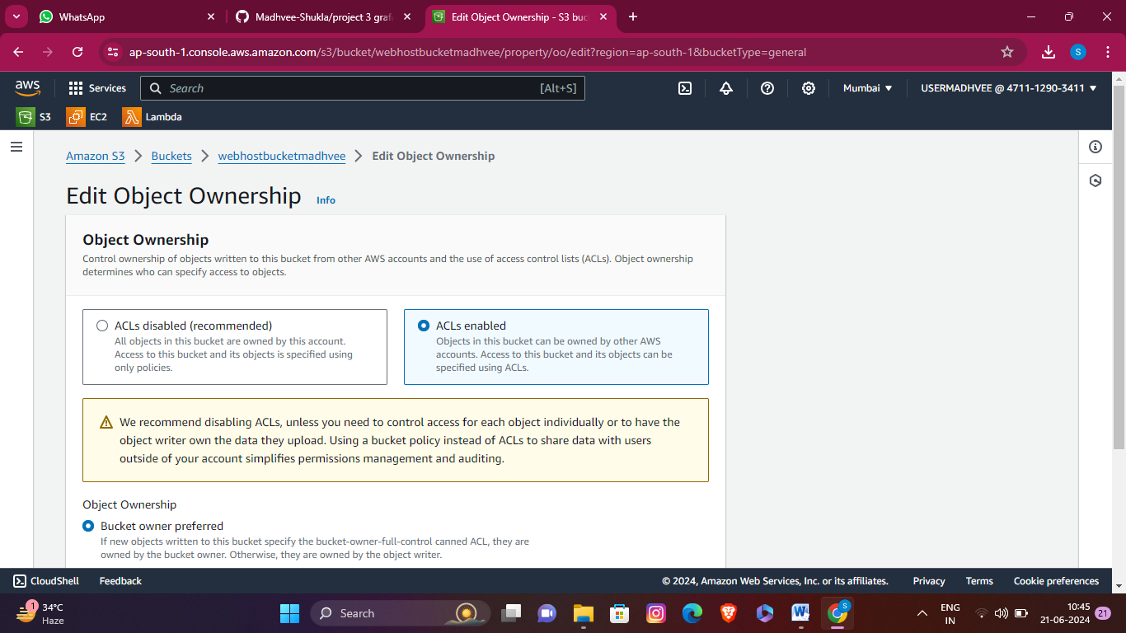

\****save changes***.

*Then we select our file html and touch the actions then we enable ***make public* *using ACL***

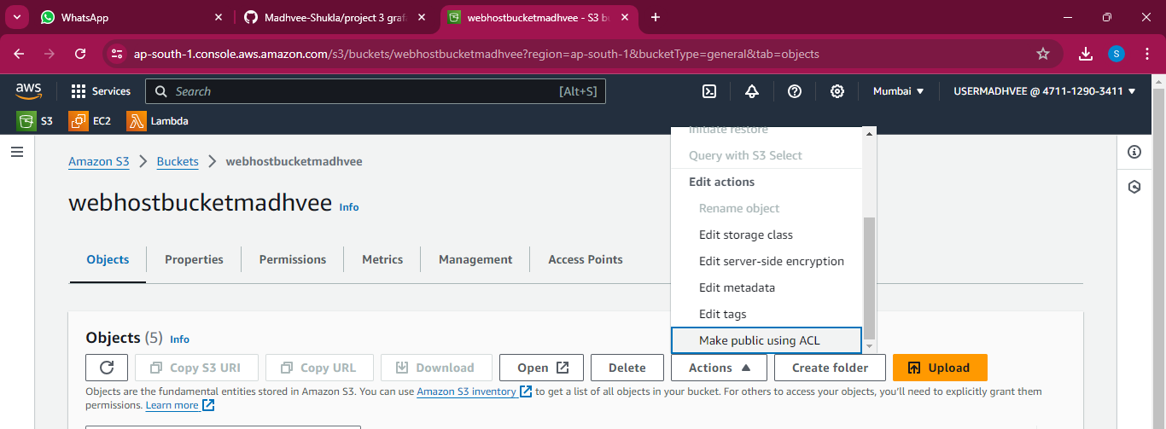

*Now, we will copy object URL.

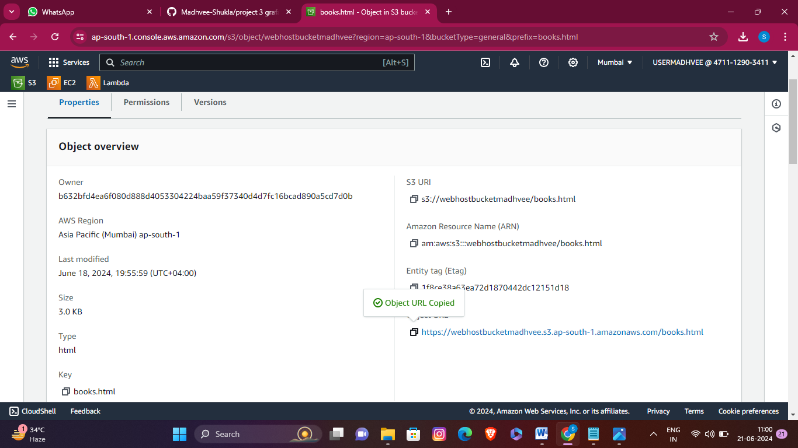

As, we copied the object URL we will attach this link to google chrome.

[Home](https://webhostbucketmadhvee.s3.ap-south-1.amazonaws.com/books.html#home)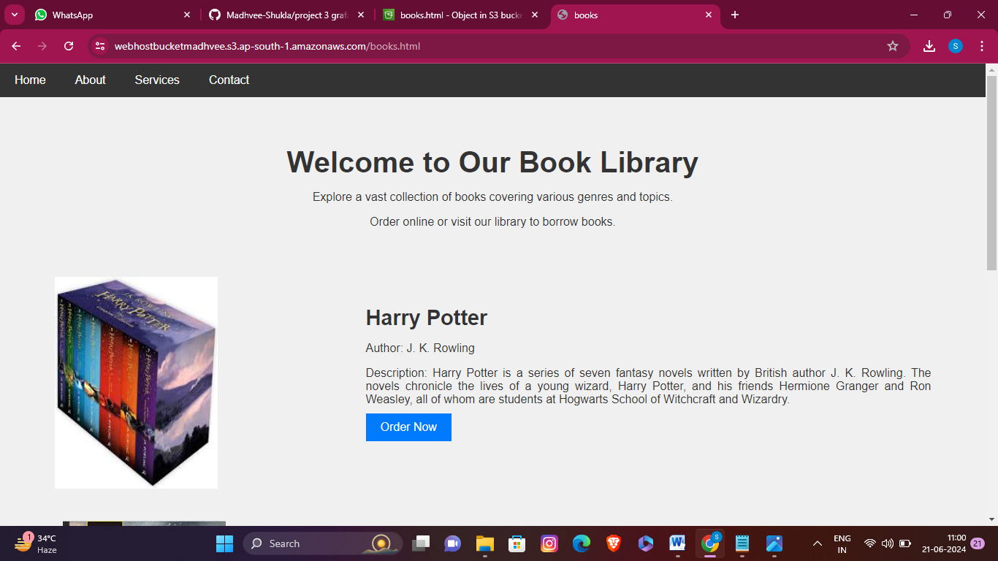

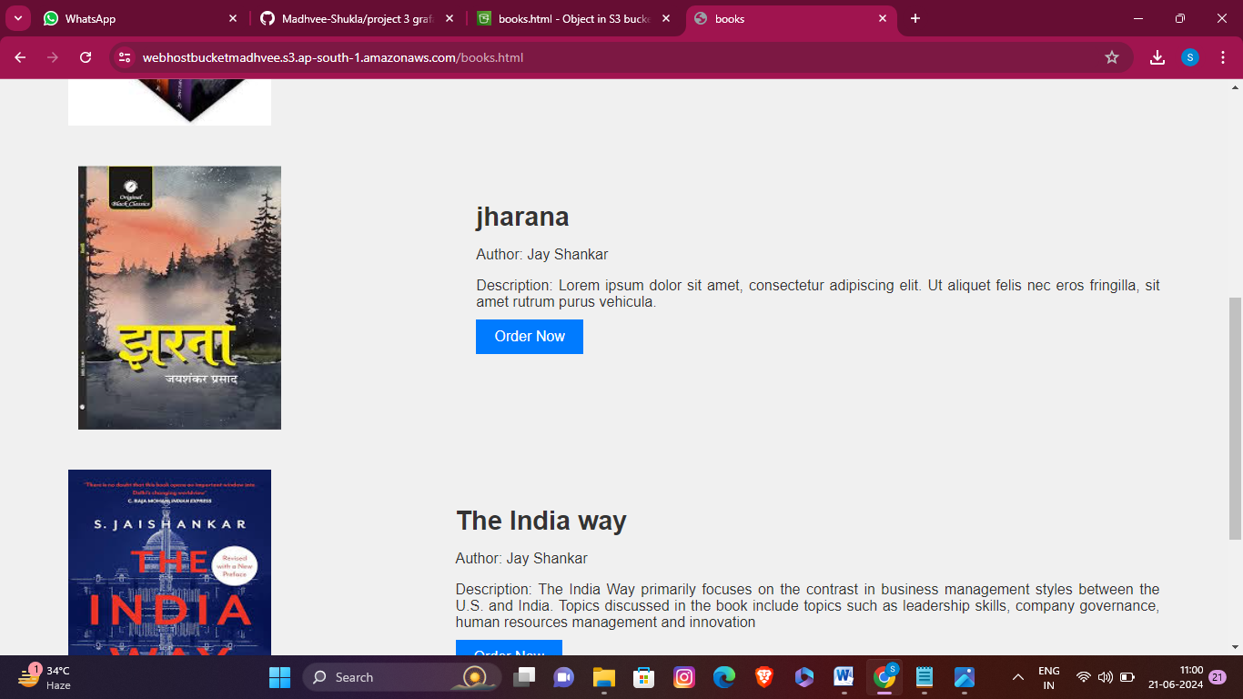

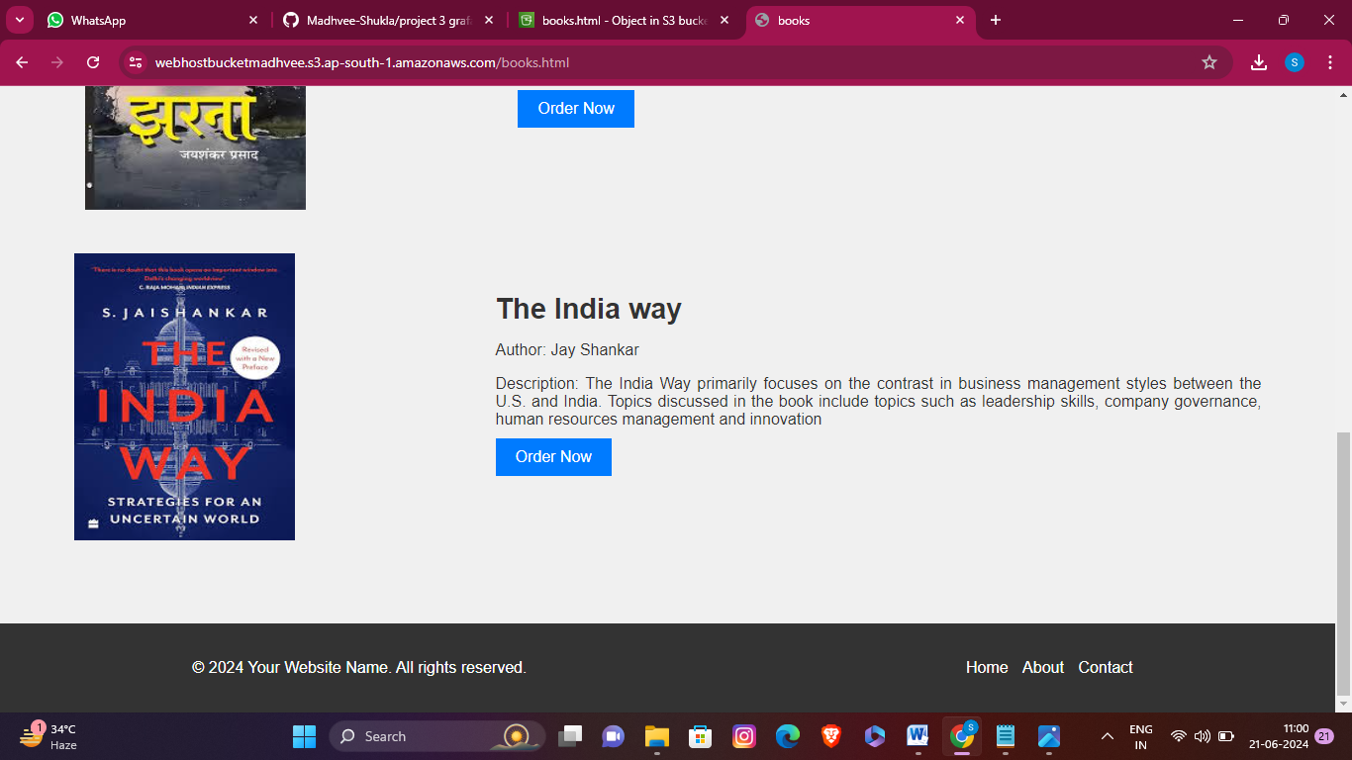

[About](https://webhostbucketmadhvee.s3.ap-south-1.amazonaws.com/books.html#about)

[Services](https://webhostbucketmadhvee.s3.ap-south-1.amazonaws.com/books.html#services)

[Contact](https://webhostbucketmadhvee.s3.ap-south-1.amazonaws.com/books.html#contact) step 4-

#Make a css file and upload it in s3 bucket

body {

font-family: Arial, sans-serif;

margin: 0;

padding: 0;

}

nav {

background-color: #333;

overflow: hidden;

}

nav ul {

list-style-type: none;

margin: 0;

padding: 0;

}

nav ul li {

float: left;

}

nav ul li a {

display: block;

color: white;

text-align: center;

padding: 14px 20px;

text-decoration: none;

}

nav ul li a:hover {

background-color: #555;

}

header {

background-color: #f0f0f0;

color: #333;

padding: 40px 0;

text-align: center;

}

.header-content {

max-width: 1200px;

height: 1181px;

margin: 0 auto;

/* display: flex; */

justify-content: space-between;

align-items: center;

}

.library-info {

flex: 1;

text-align: center;

}

.library-info h1 {

font-size: 2.5rem;

margin-bottom: 10px;

}

.book-info {

/* flex: 1; */

display: flex;

justify-content: space-around;

align-items: center;

padding-top: 50px;

}

.book-image {

width: 305px;

height: 284px;

/* overflow: hidden; */

}

.book-image {

paddiing-left: 30;

}

.book-image img {

width: 223px;

height: 290px;

}

.book-details {

text-align: justify;

height: 252px;

margin-top: 100px:

}

.book-details {

padding-left: 203px;

}

.book-details {

}

.book-details h2 {

font-size: 1.8rem;

margin-bottom: 10px;

}

.book-details p {

margin-bottom: 10px;

}

.book-details button {

background-color: #007bff;

color: #fff;

border: none;

padding: 10px 20px;

font-size: 1rem;

cursor: pointer;

}

.book-details button:hover {

background-color: #0056b3;

}

footer {

background-color: #333;

color: #fff;

padding: 20px;

text-align: center;

}

.footer-content {

max-width: 960px;

margin: 0 auto;

display: flex;

justify-content: space-between;

align-items: center;

}

.footer-content p {

margin: 0;

}

.footer-content ul {

list-style-type: none;

padding: 0;

}

.footer-content ul li {

display: inline-block;

margin-right: 10px;

}

.footer-content ul li a {

color: #fff;

text-decoration: none;

}

.footer-content ul li a:hover {

text-decoration: underline;

}

Here, we have taken the code of css the saved it in notepad with the extension of style.css.

*Now, we will go to the s3 bucket and upload this css file.

*once we uploaded our file then we will go to the objects and click the file.

*We will also check properties and permissions of file .In ***properties*** we ***enabled our static webhosting***.

*we go to the ***permission tab*** and edit *block public access* ***from on to off*** then we edit ***object ownership*** and select ***ACLs enabled*** then ***save changes***.

*Then we select our file css and touch the actions then we enable ***make public* *using ACL***

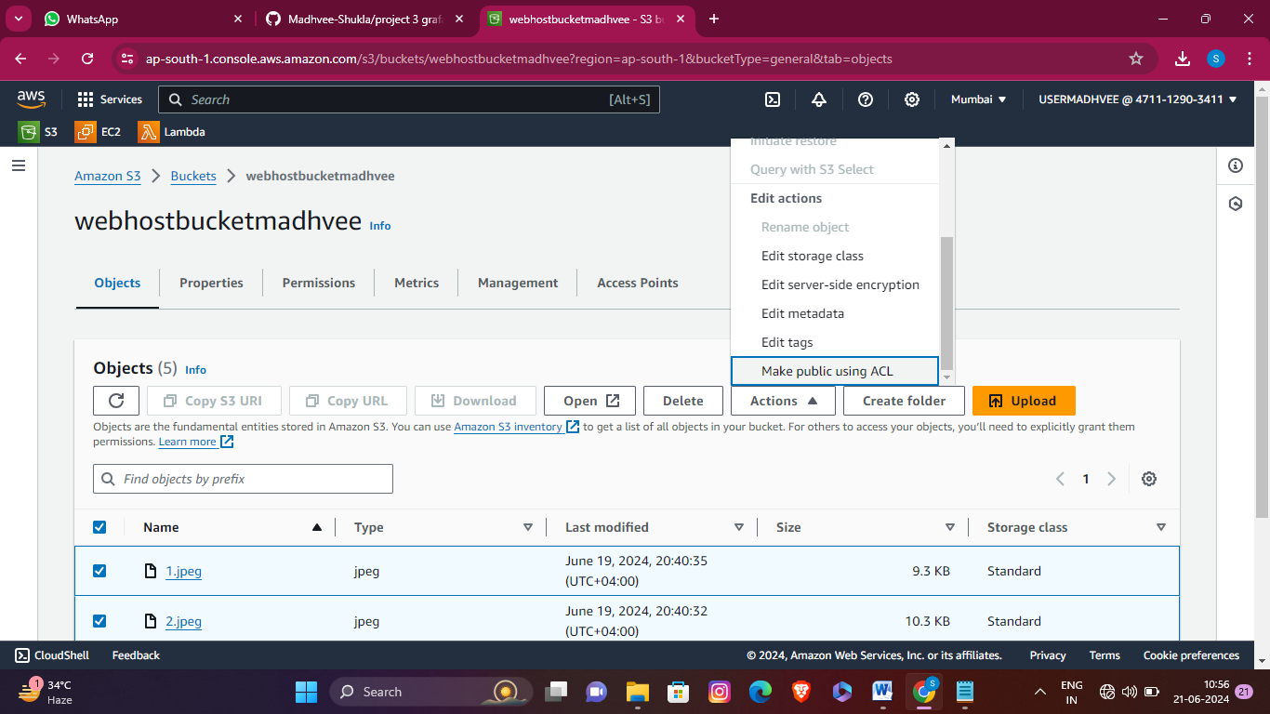

*Now, we will copy object URL.

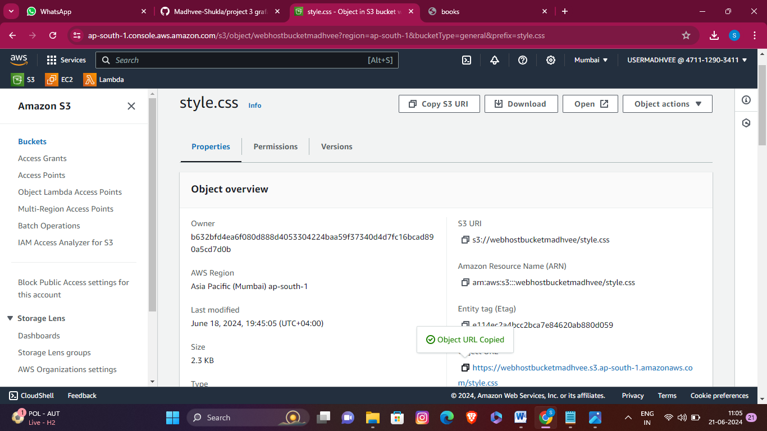

As, we copied the object URL we will attach this link to google chrome. Then we get our output.



